ThermaSkirt User Manual

Step 1 – Draw the Whole Room Outline

Click on ‘Start’ or Go to File Menu and Click on ‘New’ or ‘Open’ to start the program. Clicking on Start or New option from the menu will open the designer in ‘New’ mode where you can start designing your room while Open option will let you to open any existing ThermaSkirt designer files (.tsd). Let’s start by choosing the ‘New’ option.

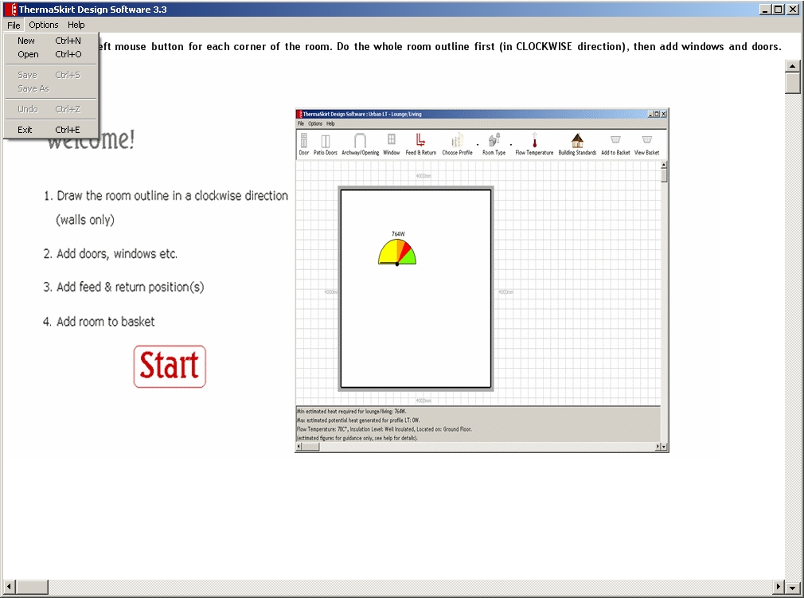

The next step will be to define the building standards for your room along with the design temperature, i.e. whether the room is very well insulated or poor insulated and what the outside temperature for your room.

You can set the required values over here which will assist the system to calculate the exact values for heat gain and heat loss for your room. By default the building standard is set to ‘Well Insulated’ and temperature is set ‘-3’, outside temperature.

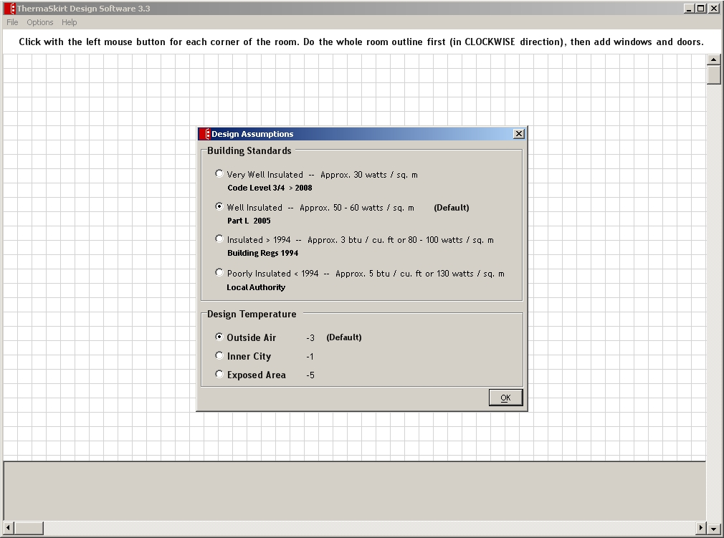

Once you set the building standards and the room temperature, then you have to tell the system about the location of the room, whether it is on Ground floor or first floor, that will result in setting the appropriate ‘U’ values for the room which in fact too result in getting the right heat loss calculation. The default value is set to ‘Ground Floor’.

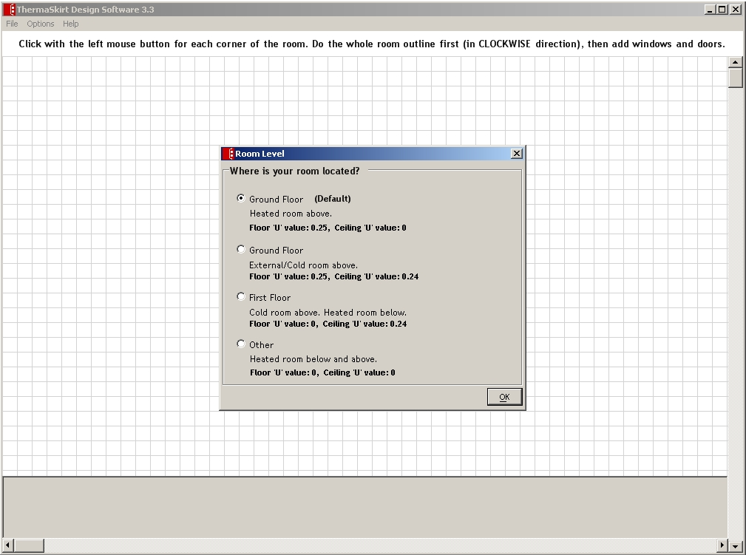

Once all set, you will have the following screen in front of you. Start by clicking with the left mouse button where you wish to place the first corner of the room.

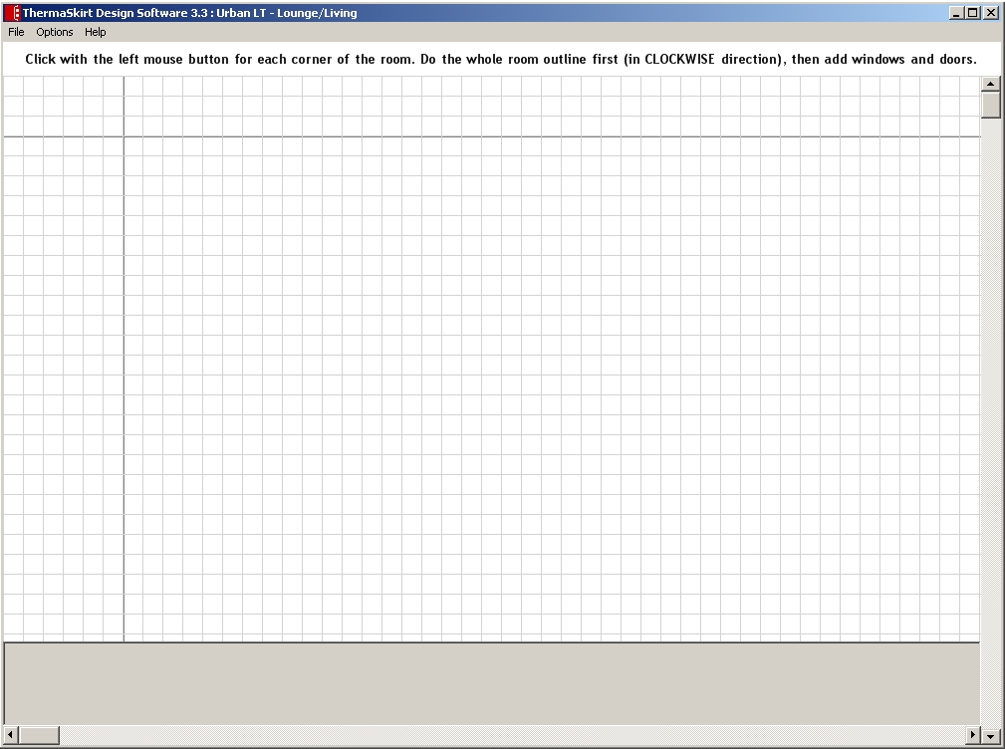

As you move the mouse you will see the wall “stretch”.

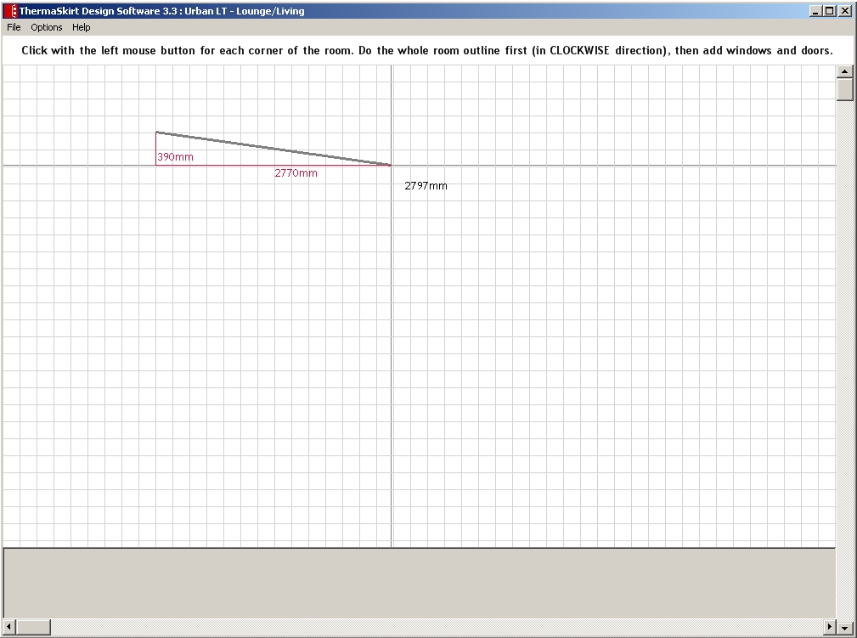

Stretch the wall to the approximate length (it doesn’t have to be exact, as you’ll see in a moment.

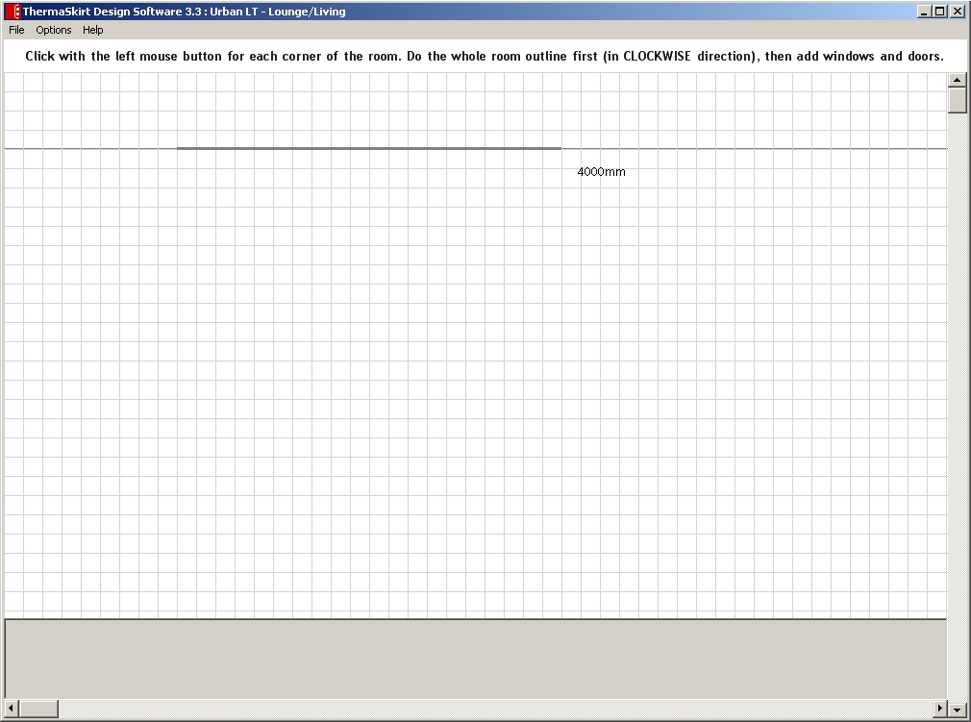

Then click with the left mouse button at the end point of the wall. You will then see a screen where you can “fine-tune” the length of the wall (to the nearest mm). You can also determine the height and type of wall (these are used in calculating the heat requirement for the room). Once you have entered the correct details press “OK”, otherwise press “Cancel” to undo the wall.

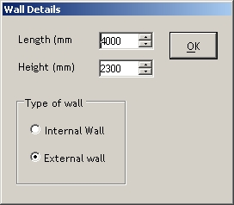

Repeat the process for the other walls:

The last wall needs to meet up with the first wall to complete the room. (There is a shortcut method which is to press the RIGHT mouse button and it will complete the last wall automatically).
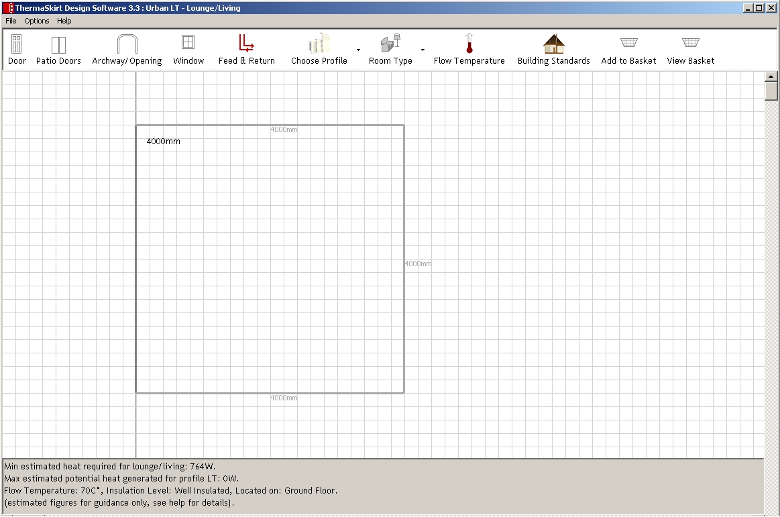

You should now see your basic room outline ready for the next stage.

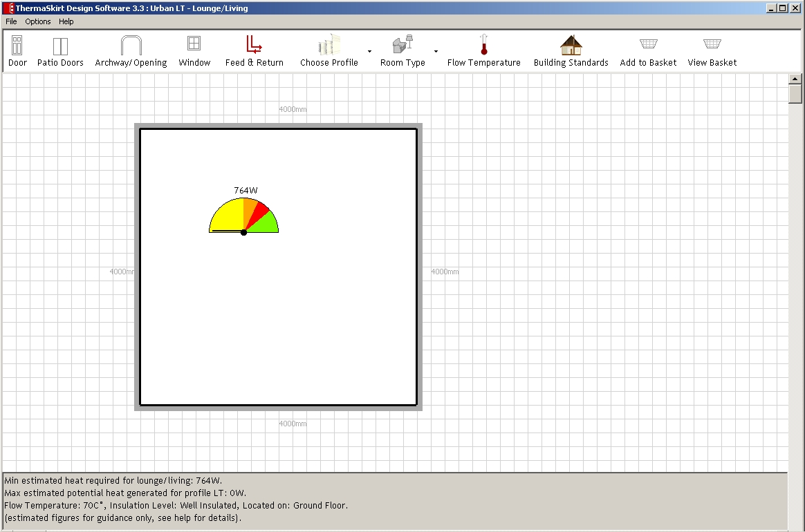

At any stage, if after completing the wall and setting its length you are not satisfied with the wall or if you want to cancel it or got back to the previous stage, Press ‘Ctrl + Z’ or click on ‘Undo’ in File menu above. This will take you back to the ending of your previous wall.

Step Two – Place Windows and Doors

The next stage is to place doors, openings, windows etc on the walls. You can do this in any order you like, and you can add and remove in a very flexible way.

To add a door, for example, click on the “Door” button on the toolbar at the top then move the mouse to the wall where you want to place the door.

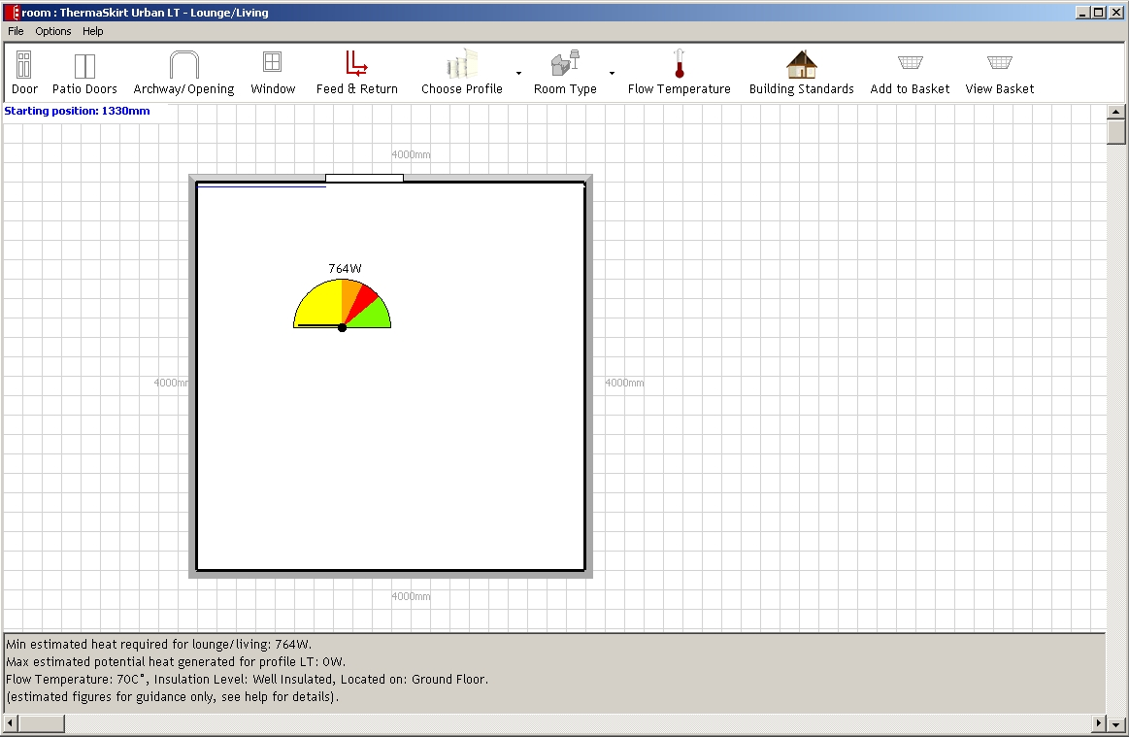

As you move the mouse up and down the wall you will see a “Starting position” in the top left hand corner. This shows how far along the wall the door is to be placed. Click with the mouse to fix the door in place (again, it does not have be exact as you’ll see in a moment).

You will see a window showing the details of the door as follows:-

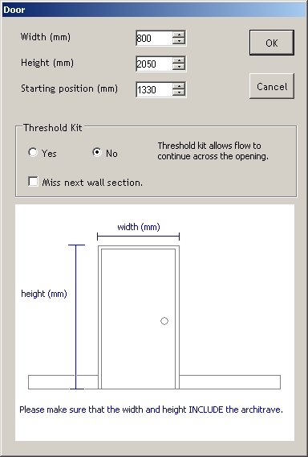

You can fine-tune the width, height and starting position of the door to the nearest mm. The width is critical and should be measured from the OUTSIDE of the door architrave as shown in the illustration. The height is less critical and is used only in the heat calculations for the room.

When you have the entered the correct details, press “OK”. If you wish to undo the door, then press “Cancel”.

You should then see something like this:

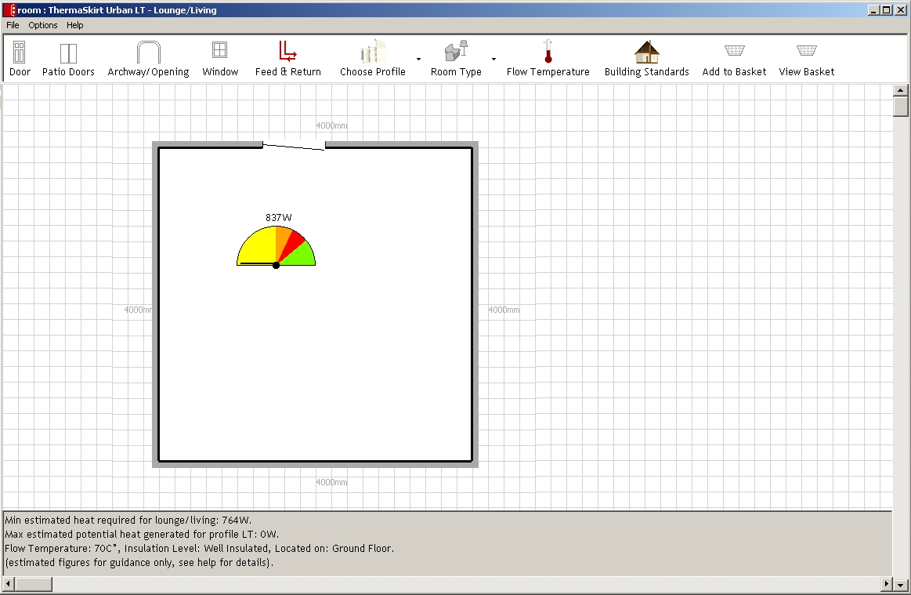

(By the way the opening of the door is purely for illustrative purposes, so do not worry that it should be outward opening or hung on the other side.)

If you decide you need to change the door details (or delete it), just click on the door again.

Repeat the process for any other doors, windows and openings.

Some points to note:
- Do not overlap doors and windows; if you have a window above a door just treat it as one combined door.
- If you have a window which interrupts the skirting (i.e. the window goes down to the floor), then treat it as a door.
- If you can’t position the opening accurately then position it as near as possible and use the details screen to complete.
- If the opening is too large for the wall then it will be truncated if possible, or you will see a message saying that it can not fit in your intended location.
- It is possible to stretch walls after openings have been placed, but walls can only be stretched in the direction that you have originally drawn them, so you may not get the desired result.

Step 3 - Add ThermaSkirt

You may have noticed that the skirting so far has been shown in black.

The software will assume that you wish to have matching skirting in a room (if you do not then please contact Discrete Heat).

To activate the skirting you first need to place a “Feed and Return” point. This is the unit which connects ThermaSkirt to your central heating and has a thermostat control. The unit needs to be reasonably accessible to allow you to set the operating temperature of the ThermaSkirt.

To place the “Feed and Return” point, click on “Feed & Return” on the toolbar and move the mouse to the target wall. As with windows and doors you can see the approximate location on the wall from the “Starting position” in the top left hand corner.

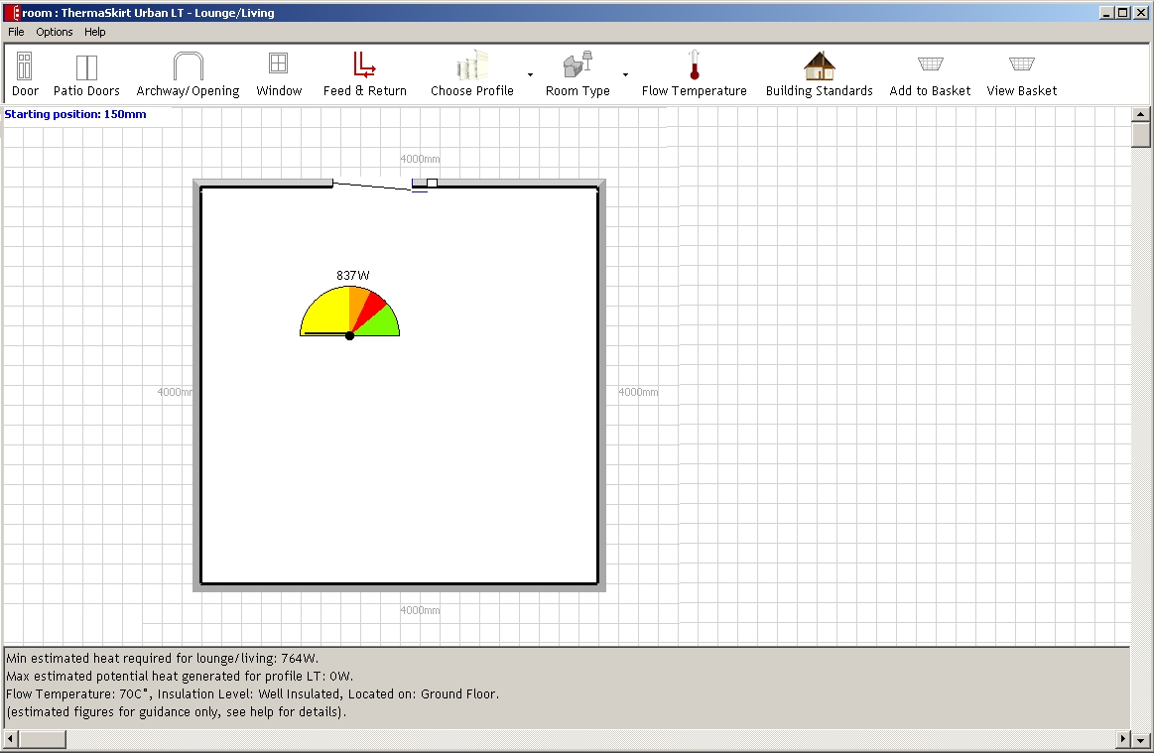

Use the left mouse button to fix the Feed & Return point in place and you will see the following details screen:-

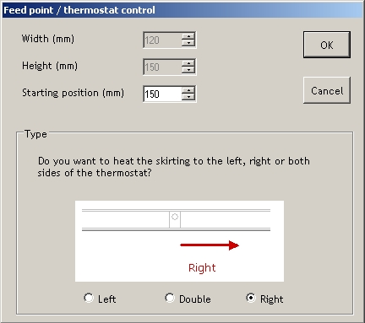

Choose the direction of flow, (left, both, or right) and fine-tune the starting position. When you have entered the correct details press “OK”. If you wish to undo this action just press “Cancel”.

The software will automatically connect all adjoining skirt sections.

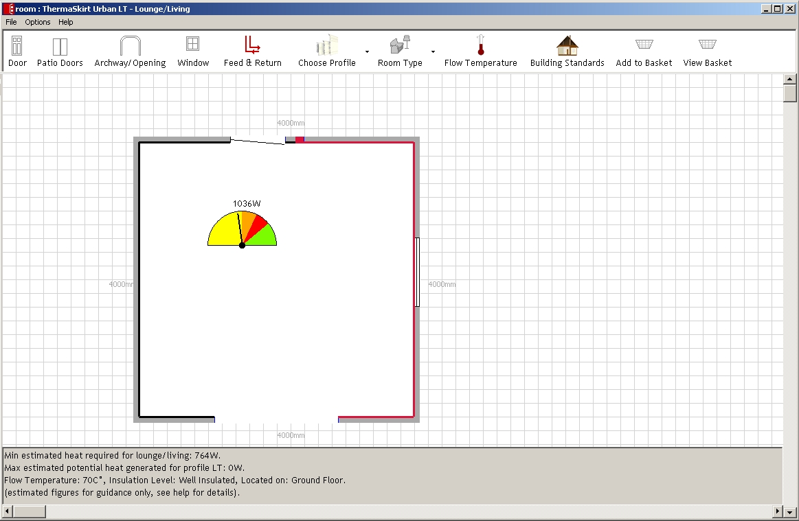

If you wish to bridge an archway/doorway/opening then select it with a left-mouse click to display the details and select “Yes” for the threshold kit.

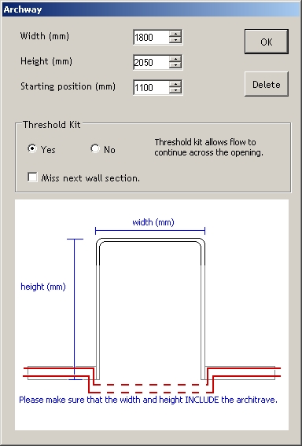

Threshold kits are shown by a dotted red line.

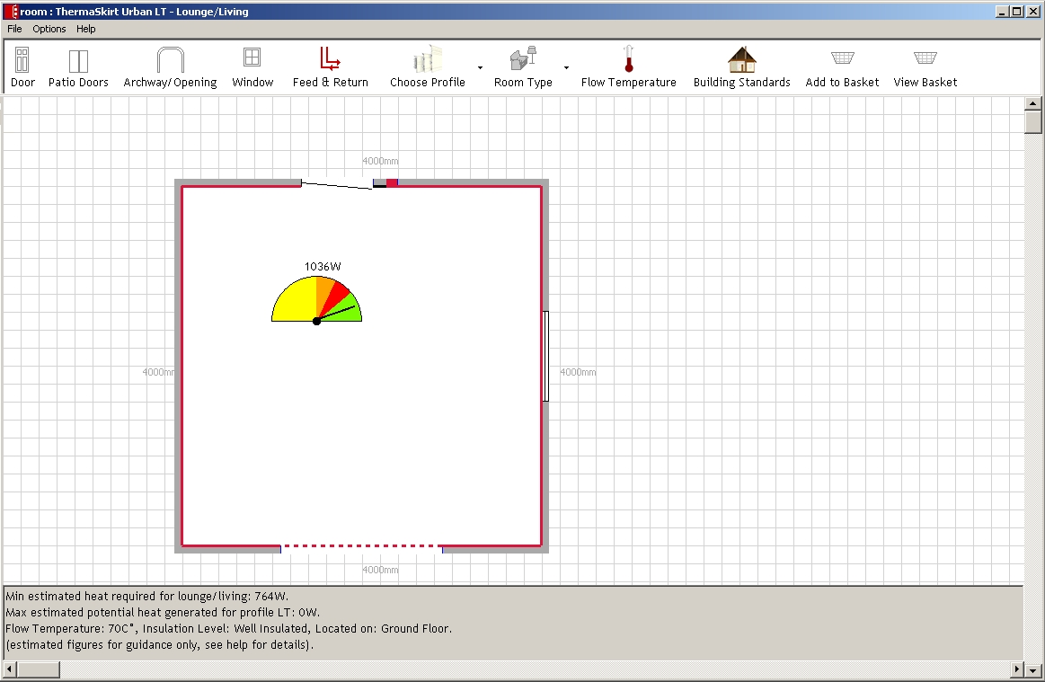

Estimated Heat Indicator

In the middle of the room you will see an “Estimated Heat Indicator”. Provided that the gauge is in the green area you should have sufficient heat to keep the room at a comfortable level on a cold day. Please note that heat calculations are based on several assumptions which are explained in Help > Heat Calculations on the menu bar at the top. The indicator does not guarantee the actual warmth experienced in the room.

You can change the assumptions behind the calculations by selecting a different “Room Type” from the toolbar at the top of the screen. It will default to “Lounge/Living”, but there are other common room types for you to choose from. If your room is not listed then select as similar type as possible.

You can switch the gauge off at any time from the “Options” menu.

Points to Note:
- It is not possible to connect very short lengths (less than 75mm) of skirting.
- Threshold kits are limited to 4m openings.
- Feed and Return Points within 75mm of the start or end of a skirt section will be moved to the start or end of the skirt section.

Step 4 – Add To Basket

When you have completed your room you can save it by selecting File > Save from the menu bar (Ctrl-S shortcut).

You can then add it to your basket by clicking on the “Add to Basket” button on the toolbar.

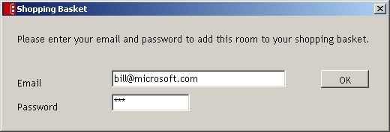

When you first click on the button you will be asked for your email address and password (which will have been set up when you downloaded the software). If you have forgotten your password then go to www.thermaskirt.co.uk and request a reminder.

After you have entered your password (you only need to do this once per session) you can then choose the finish and profile for skirting.

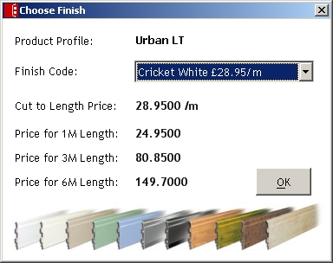

When you press “OK”, it will add the room to your basket. If you have more than one basket on ThermaSkirt Website, the system will show you all of your available baskets and you can select your desired one to add your room. Otherwise, the room will be added to your default basket.

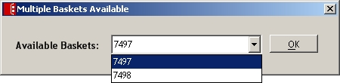
Once added, you will get this confirmation from the system.

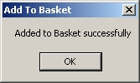

You can add one or more rooms to your basket. If you add a room twice it will overwrite the previous one.

Should you wish to view your basket then press the “View Basket” button on the toolbar?

It will take you to the ThermaSkirt website, sign you in, and display your basket using your default web browser.

You can return to your basket at any time, and you can access your basket directly through your web browser as well.

