

Easier Fitting Internal Classic TS Corner Covers

Following feedback from our network of installers, we have adopted a new method of manufacturing to ease installation of the Classic cover.
As the profile is screwed directly to the wall, occasionally, walls that were not perpendicular could cause fitting problems.

To combat this, we are adopting the technique employed by a number of our fitters and producing the Classic TS internal corners in 2 halves

Previously the cover would have been fixed and welded at 90 degrees which gave less scope to accommodate the variations in angle and perpendicularity of older property walls. Now the covers are supplied with a high-tensile flexible woven tape bonded on the back to secure the 2 halves to each other, but with a tremendous degree of manoeuvrability.
This will allow for much greater flexibility during installation and much faster installation.

The corners are simply clicked into place as usual, whilst the centre line of the mitre joint will require a small bead of exterior grade flexible decorators caulk to finish off plus a dab of glue at the top.

Please see the illustration below:

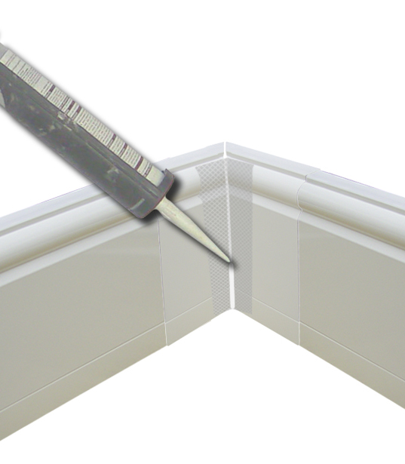
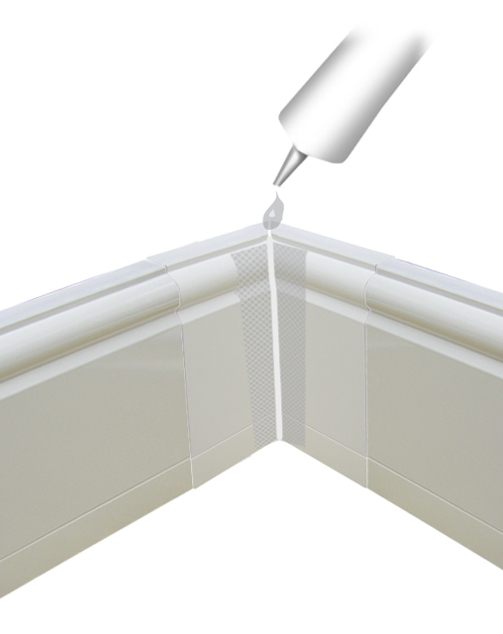

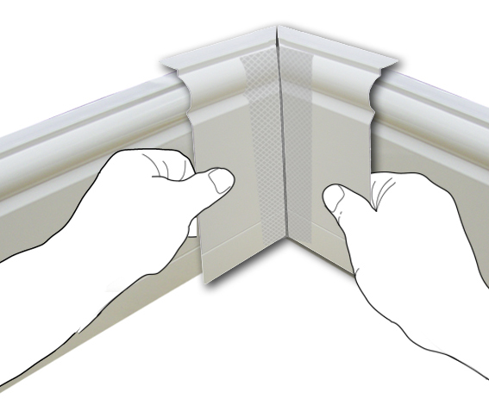

If you have any questions concerning installing these covers please contact the office on 01942 880060 or e mail in to info@discreteheat.co.uk

